**Introduction to Pinterest**



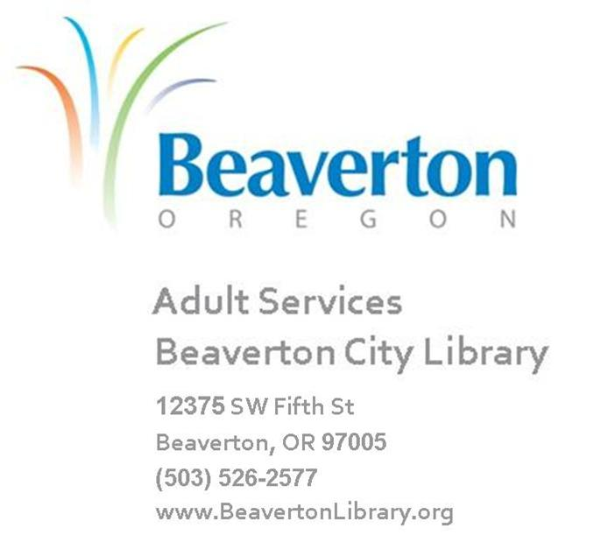

**Table of Contents**

Welcome 3

1. Introduction 4

Let’s Talk About Social Networking Online 4

Use Common Sense and Be Safe Online 5

1. Let’s Get Started with Pinterest 6

Registering with Pinterest 6

Setting up with Pinterest 7

About Pinterest 8

Editing Your Personal Profile 9

Upload a Pin 10

Create a Board 11

Exploring with Pinterest 12

1. Titles at Beaverton Library That May Be Helpful 13
2. Glossary 14
3. Class Evaluation

**Welcome!**

Welcome to the Pinterest class at Beaverton City Library! We hope this class will help you become more familiar with Pinterest and boost your confidence in participating in this exciting online adventure. Please remember to be patient with yourself during this class---we want it to be fun as well as informative!

Social networking online is communicating electronically with friends, family and other like-minded individuals. While there are many methods of social networking online, we will be focusing on learning about and participating in the social networking community that is called “Pinterest”. We will first discuss the importance of using common sense while online and we’ll also point out safety guidelines and precautions for keeping safe.

By the end of this course, you will be able to:

* Network online safely and confidently
* Find followers online
* Create an online personal profile
* Participate in an online community

There are so many aspects of social networking that we cannot cover them all today, but the above list will help get you started in the online community in a safe and fun environment in our classroom. Please ask questions as you think of them, and be sure to have fun!

**Remember:**

Depending on your software, your screens may vary slightly from the screens shown in this handout. Also, most web pages will evolve over time. Hopefully this class will help you navigate the online community with confidence.

**Introduction**

Objectives

* Discuss social networking terminology
* Learn the benefits of social networking online
* Review common sense and safety online

**Let’s talk about Social Networking Online**

**Social networking online** is communicating electronically with friends, family and other like-minded individuals usually through an online community such as Facebook, Twitter or Pinterest (there are many others as well).

**Chatting** is a way to communicate online in *real time* using typed messages (also called instant messages). It’s a bit like email except that the person you’re ‘chatting’ with is typing messages to you and you are returning typed messages in answer after they send their text message. It is offered through most email programs and social network sites.

A **Blog,** or **web log,** is a website that displays postingsfrom individuals about certain topics or issues and then displays them in reverse chronological order, with the most recent post appearing first. Blogs can be created on any topic.

**Social networking communities** allow members to create a personal profile from which they can chat, blog, and post photos all on one website. In this class, you will join the *Pinterest* community and learn some of the features available to you as a Pinterest member.

Social networking communities allow you to reconnect with old friends, make new friends, share postings, photos, and links and many other things that you’ll discover as you use the social network community of Pinterest that we’ll show you today.

**Use Your Common Sense and Be Safe Online**

It’s important for you to understand how to network wisely, and to protect yourself against scams, hackers, and viruses. Follow the tips below when communicating online.

* Install and maintain virus protection software.
* Reliable websites post statements regarding your privacy. Read *privacy statements* before using websites to be sure they will keep your enrollment and payment information confidential.
* Keep passwords in a safe place and never share them with others.
* Remember that online conversations are not private. Never type anything that you wouldn’t put on a public bulletin board.
* Think before you post a photo or type personal information or feelings online. It is nearly impossible to remove information from the internet once it has been posted.
* Never send financial information over the Internet such as social security, bank account, or pin numbers.
* Don’t provide contact information such as your full name, phone number, or address when creating an online profile or chatting with people you have only met online. Retaining a certain amount of anonymity online will help keep you safe.
* Never conduct financial transactions with people you have only met online, i.e. cashing checks or wiring money.
* Be sure to completely log out of email and online communities when you are finished so that no one else can use your account.
* Trust your gut if you have suspicions. If you ever feel uncomfortable or threatened by anything online, log out of that site or stop opening mail from that sender. If necessary, report that sender to the website.
* To learn more about safety online and common interest scams, or to learn how to file a complaint against an online fraudster, go to the Federal Trade Commission’s website [www.onguardonline.gov](http://www.onguardonline.gov).

**Let’s Get Started With Pinterest**

Objectives

* Create a personal profile on Pinterest
* Find Pinners and Boards to follow
* Learn about your personal profile and how to edit it

**Registering with Pinterest**

Pinterest is a tool for collecting and organizing things online, such as pictures and links. You pin interesting items on to boards that are organized by subject. For example, let’s say you’ve found a link to a cute cat picture. You can join, or create a board on cute cats and pin your link there. That way you can share it with others and be able to find the picture whenever you want.

1. Go to pinterest.com. From there, click **Join Pinterest**. You have some options here. You can connect through your Twitter or Facebook account, or sign up with your email address. Let’s do the email route. Click **your email address**.

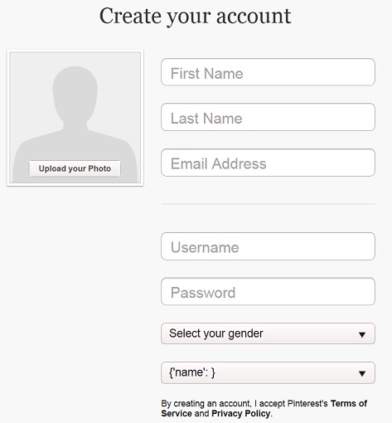

Click the down arrows to see the list

2. You will need a username, a valid email address, your full name and a password. You will also need to indicate your gender and location. From here you can also upload a photo for your profile picture, but we can also do this later. Click **create account.**

Write down your **Pinterest** Login

Remember This

Information below:

**User Name:** ________________________________________ (e.g. Snow White)

**Email Address:** ______________________________ (e.g. Doc@yahoo.com)

**Pinterest Password:** _____________________________________ (e.g. Sleepy77)

3. Next they would like you to follow 5 boards to get started. The left side is a list of categories. Select one that appeals to you. It will open on the right a list of popular boards about your interest. The previews each show the name of the board, the creator, 5 pictures from the board, and the button in red that says **Follow**.

4. Select 5 boards that interest you by clicking **Follow**. To unfollow, click the red button that now says **Unfollow**. You can change them later too. Once you’re done, click **Next.**

**Setting Up with Pinterest**

* . A pop up will come up welcoming you to Pinterest. They recommend taking the tour to help get started. Click **Take Tour**.
* The page behind the pop up is your **Home Feed**. Like Facebook or Twitter, the home feed updates when the board you are following posts new pins. The display will show the newest content first. Click **Next.**
* The upper left corner has a red button with three white lines. This will show all the categories of boards.
* The upper right corner has a red push pin and your first name. This is your profile menu to access your pins, boards, find friends, help center, log out and settings.
* The Pinterest in the upper center is the home link. If you ever find yourself off track or feeling lost, think of this link as an escape hatch. It will take you right to your home page.

Now that the tour is over, you’ll notice a request to confirm your email. Go to your email, find the confirmation email from Pinterest and click **Confirm Email**. This will take you back to Pinterest and your registration is complete!

**About Pinterest**



6. Notifications

3.Home

1.Categories

4. Add Menue

2. Search

5. Profile Menu

1. The 3 lines in the upper left corner accesses the categories of boards.
2. The search bar allows for keyword searches. Results can be sorted by Pins, Boards or Pinners. You can also sort results by showing pins from either All Pins or Just my Pins.
3. The middle Pinterest logo is a persistent link to your **home page**.
4. The plus sign is a menu to upload a pin, add from a website, and create a board.
5. The push pin next to your first name opens up your boards, your pins, etc.
6. To the very upper right is an icon of two pushpins with one facing up and the other facing down. This is your notifications section.

**Edit your Profile**

* To edit your profile, click the pushpin by your name. Then click **Your Boards**. You will see a large picture of the pushpin icon next to your full name. In the bottom right of that box is a small grey pencil icon. Click that to edit your profile.

Click for Profile

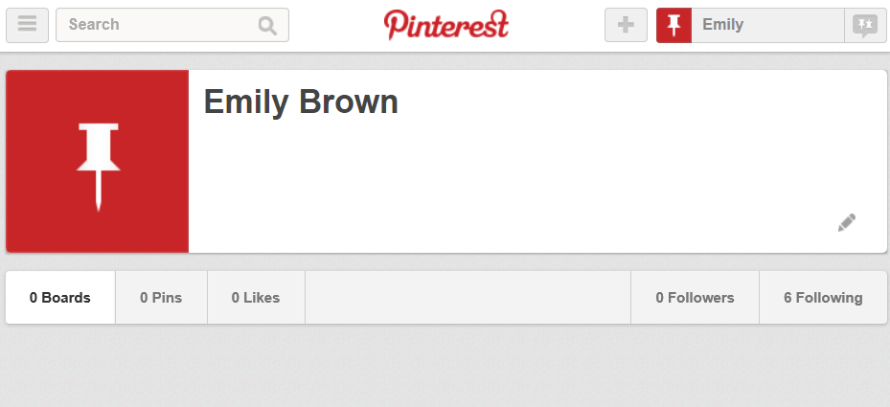

Profile Page

Click to Edit

* In **Edit Profile**, you can change your name, username, put in a small bio in the *About You* section, your location, and a personal website. If you do enter in a website, you will need to click **Verify Website**. After your edits are done, click **Save Profile**.
* To edit your **Account Settings**, click the small pushpin next to your first name in the upper right. Then, click **Settings**. This will allow you to change your email address, password, language, country, gender, and others. You can adjust your email notifications from Pinterest. You can also connect your Facebook and Twitter to Pinterest. And finally, if you were to deactivate your account, you would do it from this page.
* From your **Profile** page you can also see your **Boards**, your **Pins**, your **Likes**, your **Followers** and see who’s **following** you.

**Upload a Pin**

* There are two ways to upload pins. You can use **Upload a pin**. Click the plus sign icon in the upper right. Then click **Upload a pin**.

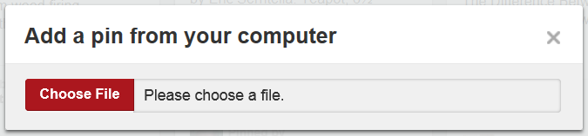

* This opens the dialog box above. This allows you to upload an image or video from your computer. You’ll need to know the location of the image or video on your computer. An easy way to do that is to save the image or video on your desktop.
* You can also use **Add from a Website** which allows you to add a pin from a website. You will need the web address to do this. Once you’ve entered in the website address and clicked Find Images, Pinterest will show you a list of pins from that website.

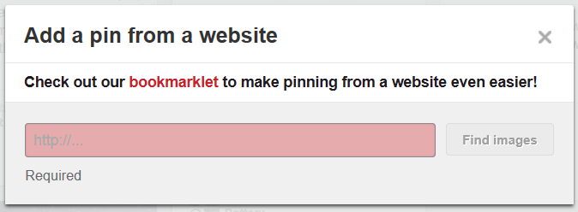

**Create a Board**

* To create a board, click the plus sign icon in the upper right. Then, click **Create a Board**.

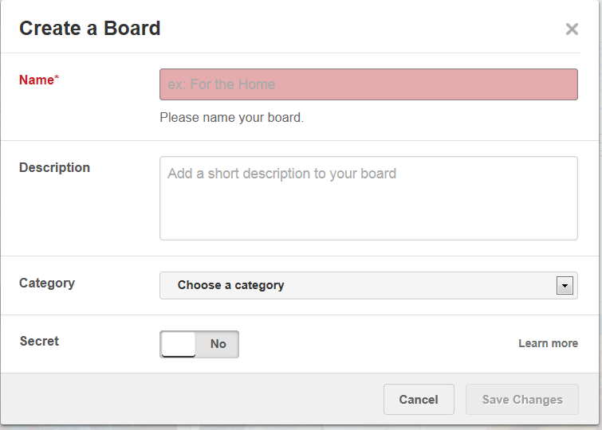

Switch moves from Yes to No

Click to see category list

Name is required

Help Menuu

* Name your board, which is required. What sort of things will be pinned on your board?
* Add a description to your board. Using our earlier example, you could say that this board, “Cute Cats”, is for pictures and links of cats being cute. This is optional.
* Choose a category for your board. Click the down facing arrow to see a list of categories to choose from. Select one by clicking once with the mouse. The selected category should show up in the box. This is optional.
* Determine if the board is secret or public. A secret board means that only you can see what is on your board. Public means that it will show up in searches or browsing. The switch next to the term **Secret** moves from Yes to No. You can edit this later.
* The **Learn more** link in the lower right will take you to Pinterest’s help menu to explain more about boards. When you’re ready, click **Save Changes**.

**Exploring with Pinterest**

* You can search for Pins, Boards, or Pinners with the search bar on the top.
* Enter in your search term and hit enter or click the magnifying glass.
* The default is to show Pins. Note the tabs on the top of the search results that show **Pins**, **Boards** and **Pinners**. If you were searching for a fellow Pinner, you would search their name and then click Pinners to have the results only show Pinners.
* Each Pin result shows the image that was pinned, a text title, the number of repins, the number of likes, the original pinner, and the name of the board it was pinned onto.

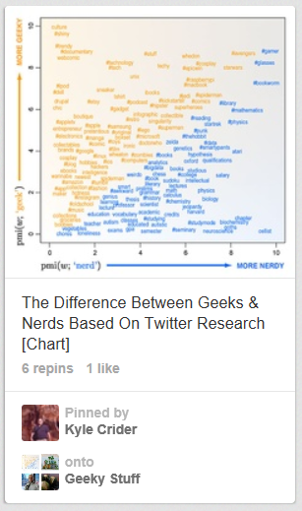

Board Location

Original Pinner

Likes

Text Title of Pin

Repins

Pinned Image

* Write down your Pinterest name on a slip of paper and give it to a classmate. Get a classmate’s Pinterest name. Use the search bar to find your classmate on Pinterest. When you’ve found them, click **Follow**.
* Use the **Search** or **Browse** to find: new pinners to follow, pins to like or repin, and new boards to follow.

**Titles at Beaverton Library that May Be Helpful:**

*Pinterest* by Majure, Janet (2012). Library shelf location (call number): 006.754 PINTEREST 2012

*Pinterest for dummies* by Carr, Kelby (2012). Library shelf location: 006.754 PINTEREST 2012

*Pinterest kickstart* by Morris, Heather (2013). Library shelf location: 006.754 PINTEREST 2013

**Glossary:**

**Address Box:** Shows the location of a file on the computer or a web page on the Internet.

**Back Button:** An icon on the browser toolbar that allows you to view previously viewed web pages.

**Board:** where you organize your pins by topic. Boards can be secret or public. You can invite others to pin with you on any of your boards.

**Browser:** A program that displays web pages on the Internet, such as *Internet Explorer* or *Safari.*

**Buttons:** Small boxes, circles, or icons that perform a command when you click on them.

**Chatting:** Real-time, text-based conversations online.

**Close Button:** The “X” located at the top right corner of a window which, when clicked on, closes a document, window, or software program.

**Desktop:** The screen or picture that you see when you start up a computer.

**Email Address:** An electronic mailbox address usually consisting of a user name followed by the @ sign and the name of the mail server.

**Email Etiquette:** A set of rules and behavior for communicating online through email or instant messaging, also known as *Netiquette.*

**Extension:** The letters after a web site or email address, such as *.com* or *.org,* which may indicate the type of organization that created the website.

**Favorites:** A collection of favorite websites chosen by the user and available on the main menu of a browser.

**Follow**: When you follow someone, their pins show up in your Pinterest home feed.

Glossary continued

**Forward Button:** An icon on the browser toolbar that allows you to view previously viewed web pages.

**Friends:** Members of an online community whom you network with and allow access to restricted information in your personal profile.

**Home Feed**: a collection of pins from pinners and boards you follow.

**Icon:** A button with a picture or symbol of a program, file, or folder.

**Internet:** The international computer network, also called the *World Wide Web* or the *Web.*

**JPEG:** A low-resolution format commonly used for digital pictures and email attachments.

**Links:** Words, icons, or photos on a web page that take you to another page when you click on them.

**Menu Bar:** A bar near the top of a program which contains menus of commands such as *File, Edit,* and *View.*

**Navigate:** To move around between different web pages and websites.

**Personal Profile:** Information about the creator of a website, blog, or online community account.

**Pin**: an image or video added to Pinterest.

**Refresh Button:** An icon on the browser toolbar that allows you to reload a web page; also known as *Reload.*

**Repin**: a pin that has been reshared by pinning.

**Search Box:** The box on a search engine where you type in key words or search criteria.

Glossary continued

**Search Engine:** A software program used to search for information on the Internet, such as *Google* or *Yahoo!*

**Social Networking:** Communicating electronically with people who share common interests via websites, blogs, and online communities.

**Social Networking Community:** a.k.a. *Social Utility;* a website, such as *Pinterest,* that allows users to create personal profiles, pins and boards, and network with other members known as “followers”.

**Toolbar:** Provides shortcuts to menu commands, usually located just below the Menu Bar.

**URL:** *Uniform Resource Locator,* the address of a web page.

**Web Browser:** A program that displays web pages on the Internet, such as *Internet Explorer* or *Firefox.*

**Website:** A collection of web pages on the Internet.

**Web:** The international computer network, also called the *World Wide Web* or the *Internet.*